

Year 8 (Grade 7) Pre-test

English First Language

Instructions:

You have 60 minutes to complete this exam. Please write your name and school below and answer all of the following questions carefully.

Name:

_____________________________________________________________________

School:

_____________________________________________________________________

Examiner Only:
Score: ___/34

Section A: Grammar & Sentence Skills (5 marks)

1. Which sentence is grammatically correct? (1 mark)
A. After decades of research, zoologists concluded that neither great white sharks nor basking sharks were heavier than whale sharks, despite their longer size.
B. After decades of research, zoologists concluded that neither great white sharks nor basking sharks was heavier than whale sharks, despite their longer sizes.
C. After decades of research, zoologists concluded that neither great white sharks or basking sharks was heavier than whale sharks despite their longer sizes.
D. After decades of research, zoologists concluded that neither great white sharks nor basking sharks were heavier than whale sharks despite its longer size.
2. Identify and underline the main clause in the sentence below: (1 mark)
Although the lesson had ended, the students remained in their seats.
3. Which word best completes the sentence? (1 mark)
Her explanation was so ________ that even complex ideas became easy to understand.
A. vague
B. coherent
C. hesitant
D. tedious
4. Which sentence is grammatically correct? (1 mark)
A. By the time the asteroid struck, many dinosaur species have already declined.
B. By the time the asteroid struck, many dinosaur species had already declined.
C. By the time the asteroid had struck, many dinosaur species already decline.
D. By the time the asteroid strikes, many dinosaur species had already declined.

5. Which sentence is punctuated correctly? (1 mark)
A. Many paleontologists believe, that feathered dinosaurs could regulate their body temperature.
B. Many paleontologists believe that feathered dinosaurs, could regulate their body temperature.
C. Many paleontologists believe that feathered dinosaurs could regulate their body temperature.
D. Many paleontologists, believe that feathered dinosaurs could regulate their body temperature.

Section B: Vocabulary & Language Awareness (4 marks)
6. Circle the word closest in meaning to “reluctant.” (1 mark)
A. enthusiastic
B. hesitant
C. confident
D. careless

7. Circle the most precise word to complete the sentence: (1 mark)
The author’s use of imagery helps to ______ the emotional atmosphere of the scene.
A. decorate
B. confuse
C. establish
D. interrupt

8. Which sentence uses the word “significant” correctly? (1 mark)
A. The significant talked loudly throughout the lesson.
B. Her improvement in writing was significant over the term.
C. He significant forgot his homework again.
D. His other significant sent out the wrong email.

9. Write a synonym for the word “challenge”. (1 mark)

Section C: Reading Comprehension (10 marks)
The following is an extract from The Hitchhiker’s Guide to the Galaxy by Douglas Adams. Read the extract carefully and answer the questions that follow.

Extract:
The house stood on a slight rise just on the edge of the village. It stood on its own and looked out over a broad spread of West Country farmland. Not a remarkable house by any means—it was about thirty years old, squattish, squarish, made of brick, and had four windows set in the front of a size and proportion which more or less exactly failed to please the eye.
The only person for whom the house was in any way special was Arthur Dent, and that was only because it happened to be the one he lived in. He had lived in it for about three years, ever since he had moved out of London because it made him nervous and irritable. He was about thirty as well, tall, dark-haired and never quite at ease with himself. The thing that used to worry him most was the fact that people always used to ask him what he was looking so worried about. He worked in local radio which he always used to tell his friends was a lot more interesting than they probably thought. It was, too—most of his friends worked in advertising.
On Wednesday night it had rained very heavily, the lane was wet and muddy, but the Thursday morning sun was bright and clear as it shone on Arthur Dent’s house for what was to be the last time.
It hadn’t properly registered yet with Arthur that the council wanted to knock it down and build a bypass instead.
At eight o’clock on Thursday morning Arthur didn’t feel very good. He woke up blearily, got up, wandered blearily round his room, opened a window, saw a bulldozer, found his slippers, and stomped off to the bathroom to wash.
Toothpaste on the brush—so. Scrub.
Shaving mirror—pointing at the ceiling. He adjusted it. For a moment it reflected a second bulldozer through the bathroom window. Properly adjusted, it reflected Arthur Dent’s bristles. He shaved them off, washed, dried and stomped off to the kitchen to find something pleasant to put in his mouth.

Questions:

10. The house is described as “not a remarkable house by any means.”
What does this suggest about Arthur Dent’s life and expectations at the start of the extract? (2 marks)
_________________________________________________________________________
_________________________________________________________________________
_________________________________________________________________________
_________________________________________________________________________
_________________________________________________________________________
_________________________________________________________________________

11. How does Douglas Adams use irony in the description of Arthur’s house and its importance? (2 marks)
_________________________________________________________________________
_________________________________________________________________________
_________________________________________________________________________
_________________________________________________________________________
_________________________________________________________________________
_________________________________________________________________________

12. The narrator says Arthur is “never quite at ease with himself.”
How is this idea developed elsewhere in the description of Arthur? (2 marks)
_________________________________________________________________________
_________________________________________________________________________
_________________________________________________________________________
_________________________________________________________________________
_________________________________________________________________________
_________________________________________________________________________
13. How does Douglas Adams make an ordinary morning feel strange or absurd in this extract? (2 marks)
_________________________________________________________________________
_________________________________________________________________________
_________________________________________________________________________
_________________________________________________________________________
_________________________________________________________________________
_________________________________________________________________________
14. The phrase “it hadn’t properly registered yet with Arthur” is used to describe his reaction to the council’s plan.
What does this suggest about Arthur’s mental or emotional state? (2 marks)
_________________________________________________________________________
_________________________________________________________________________
_________________________________________________________________________
_________________________________________________________________________
_________________________________________________________________________
_________________________________________________________________________

Section D: Descriptive Writing (15 marks)
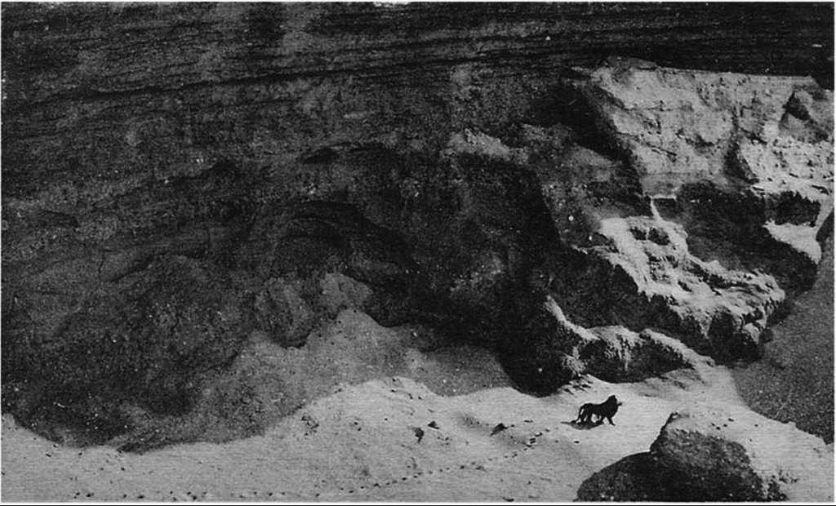
This photograph is titled The Last Barbary Lion (1924)
15. Write a short descriptive piece that captures the scene depicted in the photograph below. You should focus on atmosphere rather than action and use sensory details to bring the scene to life.
_________________________________________________________________________
_________________________________________________________________________
_________________________________________________________________________
_________________________________________________________________________
_________________________________________________________________________
_________________________________________________________________________
_________________________________________________________________________
_________________________________________________________________________
_________________________________________________________________________
_________________________________________________________________________
_________________________________________________________________________
_________________________________________________________________________
_________________________________________________________________________
_________________________________________________________________________
_________________________________________________________________________
_________________________________________________________________________
_________________________________________________________________________
_________________________________________________________________________
_________________________________________________________________________
_________________________________________________________________________
_________________________________________________________________________
_________________________________________________________________________
_________________________________________________________________________
_________________________________________________________________________
_________________________________________________________________________
_________________________________________________________________________
_________________________________________________________________________
_________________________________________________________________________
_________________________________________________________________________
_________________________________________________________________________
_________________________________________________________________________
_________________________________________________________________________
_________________________________________________________________________
_________________________________________________________________________
_________________________________________________________________________
_________________________________________________________________________

